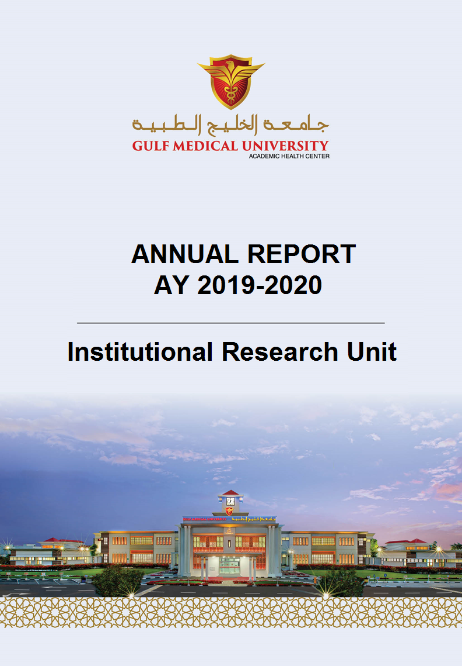

Contents
Overview of the Report 3
University Publications & Reports 3
Support in Submission of GMU institutional data to CHEDS 4
Support MoE-Graduate Destination Survey 4
Review and Revision of GMU Policies and Procedures 5
Support in National Accreditation 6
International Accreditation of GMU with Quality Assurance Agency (QAA) 7
Surveys & Feedback Reports 8
Impact Ranking - Times Higher Education 8
Stakeholder evaluation of effectiveness of the Unit 9
Support for GMU Awards and Recognition 10

Overview of the Report

The report is an annual publication of the unit and highlights its achievements against the university strategic plan. The report helps the unit to assess its scope of operations and resources and is an important tool to plan for continuous enhancement in the quality of services delivered by the unit to its stakeholders.

University Publications & Reports

The Unit is responsible for the design and preparation of the following key publications of the University

Sl. No. | Publications & Reports
1 | GMU Fact Book 2019-2020 (Link) : The fact book is designed & developed by the unit annually. It presents all the facts and figures and major achievements of the university across all its entities over the entire academic period. It also presents a consolidated view of the key performance indicators and perception indicators which form the basis of planning and decision-making function of the university. The report is accessible through GMU website.
2 | Fast Facts AY 2019-2020 (Link) : It is summarised view of the facts and figures available on the GMU website for all internal external stakeholders.
3 | Key performance indicators of AY 2019-20 (Link): The Unit is responsible for centrally managing and evaluating the institutional and key performance indicators. The unit compiles the indicators of performance annually and shares them with the colleges and program teams to facilitate monitoring of program effectiveness.
4 | GMU Operational Plan Performance Review Report AY 2019-20 (against Strategic Plan) Link  The report is a very important university publication highlighting the achievements of the colleges against the 5-year strategic plan (2017-22) of the university.
5 | Compilation of the following customized analytical reports to facilitate the preparation of the publications such as College Annual Report, College operational review report, graduating batch report and Self-Study Report.  - Faculty research Publication  - Faculty Workload  - KPIs for all domains including students, faculty, staff, research, financials, academic performance, etc.  - Survey reports  - Alumni Employability report
6. | Submission of ad hoc reports to MoE and other regulatory bodies on demand.

Support in Submission of GMU institutional data to CHEDS

Facilitate and support the following datasets for submission to the Centre for Higher Education & Statistics (CHEDs) for Fall 2019 (Link) and Spring 2020 (Link)
- Students - Enrolments
- Students - Graduates
- Students -Attrition
- Students - Scholarship
- Students - Internship
- Applicants - Basic Details
- Applicants - Academic Proficiency
- Employee - Basic Details
- Employee - Workload
- Staff - Elementary Occupations Staff
- Institute - Overview
- Institute - Leadership Contact Information
- Institute - Publications (Non-Scopus)
- Institute - R&D
- Institute - Financials
- Institute - Employers
- Institute – Surveys
- Institute - Academic Programs
- Institute - Operations

Support MoE-Graduate Destination Survey
Coordinated with the colleges and program teams to facilitate the GDS -MoE survey of GMU Alumni. The following lists the services and deliverables of the unit
- The unit verifies the list of alumni, eligible to participate in the GDS survey for the current cycle.
- The unit coordinates with the GDS team on various matters related to alumni eligibility for participation in this survey.
- The final approved list for the current survey cycle is shared by the unit to GDS team.
- Attends the GDS workshops for awareness on new trends & developments
- Called the alumni to complete the GDS survey during 6-week fieldwork period assigned by GDS-MoE.
- Critically monitor the response rate to GDS survey to ensure that the 70% benchmark set by the GDs team is achieved.
- Coordinated with program teams for extending their support to enhance the response rate through emails & verbal reminders.
- Analytical reports based on the raw responses received from GDS team is compiled as per the requirements by the colleges and the program teams.

Review and Revision of GMU Policies and Procedures
Highlights:
- A multidisciplinary and dedicated task force was formed including members from the 6 colleges of GMU and the Institutional Research Unit. The workforce met twice every week to review each policy to ensure its full alignment with the Procedural Manual for Licensure and accreditation Annexure 8 (CAA Standards 2019).
- 35 new policies were developed, and 17 policies were reviewed and revised to ensure all practices at GMU are as per the CAA guidelines and standards.
- The meeting minutes are available through the Link. (see University level>Other>Task force)
Sl. No. | New Policies
1 | Organization
2 | Terms of Reference of Standing Committees
3 | Policies Development, Document Control, Review and Dissemination
4 | Risk Management
5 | Internal Communications
6 | External Communications
7 | Program Planning and Development
8 | Program Specifications
9 | Course Substitution
10 | E-Learning
11 | Additional Degree from the same Institution
12 | Teaching and Learning Methodologies
13 | Course Syllabus
14 | Academic Misconduct
15 | Research Support
16 | Ethical Research
17 | Student Involvement in Research
18 | Commercialization of Research Output
19 | Publication Fees coverage
20 | Internal Research Grant
21 | Anti-Nepotism
22 | Degree Audit
23 | Grade Approval and Change
24 | Student Attendance
25 | Student Council
26 | Alumni Relations
27 | Equipment and Software Replacement
28 | Data Security
29 | Equipment and Software Technical Support
30 | Internal Audit
31 | Anti-Corruption and Bribery
32 | Co-operative Arrangements and Contractual Relationships
33 | Website
34 | Advisory Board and Advisory Committees
35 | Continuous Education and Lifelong Learning
Table 3: GMU New Policies
Policies and Procedures (Revised Policies)

Sl. No. | Revised Policy
 | Standard 3: Educational Program
1 | GMU-POL-S03-011 Grading and Assessment
2 | GMU-POL-S03-016 Course Syllabus
3 | GMU-POL-S03-017 Course File
4 | GMU-POL-S03-019 Regular and Intensive Modes of Course Delivery
5 | GMU-POL-S03-021 Substantive Change
 | Standard 5: Faculty & Professional Staff
6 | GMU-POL-S05-015 Recruitment
7 | GMU-POL-S05-007 Faculty Workload
8 | GMU-POL-S05-008 Professional Requirements for Teaching
9 | GMU-POL-S05-009 Faculty and Staff Evaluation
 | Standard 6: Students
10 | GMU-POL-S06-001 Undergraduate Admissions
11 | GMU-POL-S06-002 Graduate Admissions
12 | GMU-POL-S06-003.1 Admission for People of Determination
13 | GMU-POL-S06-006 Student Records
14 | GMU-POL-S06-024 Student Grievances
 | Standard 11: Community Engagement
15 | GMU-POL-S11-004-TIHWD Sponsorship Policy
16 | GMU-POL-S11-005-TIHWD Standard Operating Procedure Policy
17 | GMU-POL-S11-006 TIHWD Fee, Discount and Refund Policy
Table 4: GMU Revised Policies

Support in National Accreditation
The unit facilitated all colleges in the compilation of Self-Study reports for the following programs. The unit worked closely with the program teams to evaluate the KPIs under different domains during AY 2019-20.
- MDD
- Ph.D. Program in Precision Medicine
- BBMS
- MPH

International Accreditation of GMU with Quality Assurance Agency (QAA)

Highlights:

QAA accreditation: In Progress
- Application for participation in QAA submitted in May 2020.
- The submission of the QAA self-evaluation document is due in Jan 2021. The below stages are completed.
  - All requirements were met at the application stage and GMU was fully eligible for the scoping stage.
  - A Pre-scoping document of 60 pages was submitted in July 2020.
  - 2-day virtual visit including 7 meetings with leadership, academic and administrative staff and students was completed during August 2020.
  - A multi-disciplinary task force was constituted comprising of members from all 6 colleges and the IRU of GMU, to work on the Self Evaluation document based on the 10 European standards and guidelines of the QAA-IQR.
- Accreditation is due in August 2021.

Surveys & Feedback Reports

The following evaluations were designed and administered by the unit during the AY 2019-20
- Reports are available on the portal (Link). The reports are organized by colleges and academic year.
- The unit coordinated with colleges and program teams to ensure statistically significant response rate is achieved for each survey administered.
- Customized reports were designed and shared with the program teams for their Self-Study Reports and college annual reports.
- The unit shares the survey reports with the concerned academic & administrative units and an action plan based on the feedback report is requested for follow-up on the actions taken for improvements.

Impact Ranking - Times Higher Education
Gulf Medical University Ranked in Times Higher Education (THE) Worldwide Impact Ranking 2020
The Times Higher Education (THE) University Impact Rankings shows how the global higher education sector is working towards the United Nations’ Sustainable Development Goals (SDGs). It captures universities’ impact on society based on institutions’ success in delivering the United Nations’ Sustainable Development Goals. The impact rankings measure a university’s performance in achieving the United Nations’ (UN) 17 Sustainable Development Goals.
Highlights:
- GMU participated in the THE impact ranking for the 1st time.
- From 76 MoE accredited Higher Education Institutions in UAE, GMU ranked 3rd after University of Sharjah and Khalifa University.
- GMU achieved an overall impact rank of 601+
- GMU has achieved rank of 301-400 for three Sustainable Development Goals (SDGs) listed under THE Impact Ranking: Good Health & Well-being, Partnership for the goals, Decent Work & Economic Growth.

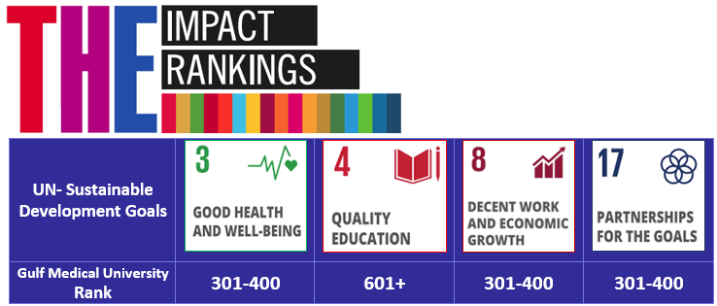

Stakeholder evaluation of effectiveness of the Unit
Institutional Research Unit is an important support unit of GMU. Its primary task is to ensure Institutional Effectiveness through the achievement of University KPIs (Key Performance Indicators) in coordination with other academic and support units of GMU. The purpose of this evaluation is to realize the strength of Institutional Research Unit (IRU) and the areas for its improvement. (Link to the feedback report). The overall satisfaction rate is above 95% and has significantly exceeded the internal benchmark of 80%.

The Action plan for AY 2020-21 as presented below is prepared based on the feedback from the survey AY 2019-20.
S. No | Problem Description | Action to be taken | Responsibility | Deadline
1. | More staff needed | 1 more staff to be recruited | VCQ&GE | Sept 2020
2. | Workload form is confusing | Online database will be established to facilitate communication and make it easy for all to understand the meaning of each item in the form | Director IRU | Nov. 2020
3. | To improve response to Employer survey of GMU graduates | - IRU will coordinate with MoE for conducting the Employer survey.  - The colleges with the support of the Alumni Office to collect data about employers of their alumni and contact the employers to build communication channel and collect their feedback. | - Associate Director-IRU  - Colleges  - Alumni Office | Mar 2021
4. | Communication with colleges | Members of QA&IE committee will coordinate communication between IRU & colleges | VCQGE | Oct 2020
5 | Support to colleges in terms of training | IRU will conduct workshops periodically on CHEDS submission, preparing the action taken reports and using the online IRU platform | Director IRU | Dec 2020
6. | Timely sharing of reports | IRU will create a cloud for sharing all reports | Associate Director - IRU | Nov. 2020
7. | To close the loop of quality enhancement | Submission of the Colleges Action Taken Reports and meeting minutes to the IRU for following up. | Director IRU | Dec. 2020

Support for GMU Awards and Recognition
2020 QS Reimagine Education Award Titled “Adapting Tomorrow Technology Today: Innovation in Medical Education with AI-Based Virtual Patient Learning”.
• GMU has won SILVER for Artificial Intelligence Category
• GMU has won BRONZE for Middle East Category
• GMU has won BRONZE for Life Sciences Category

